**System prep (packages, firewall)**

sudo apt update && sudo apt -y upgrade

sudo apt -y install git curl build-essential ufw

sudo ufw allow OpenSSH

sudo ufw allow 80/tcp

sudo ufw allow 443/tcp

sudo ufw enable

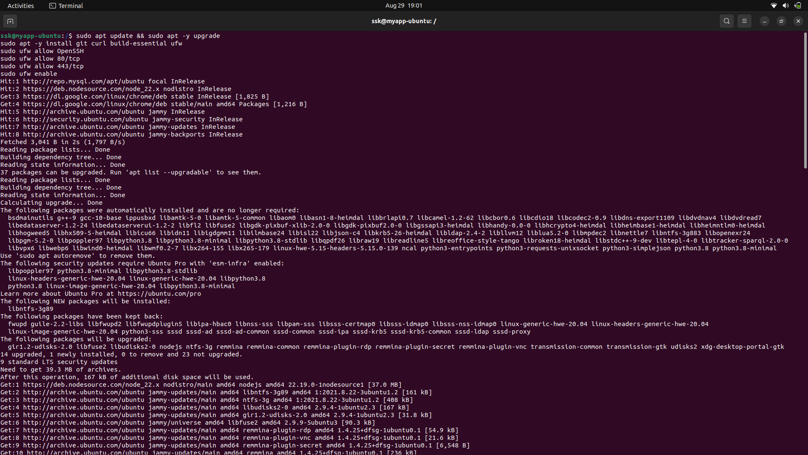

**Install Node.js (LTS) & PM2**

curl -fsSL https://deb.nodesource.com/setup_20.x | sudo -E bash -

sudo apt -y install nodejs

node -v

npm -v

sudo npm i -g pm2

pm2 startup systemd -u $USER --hp $HOME

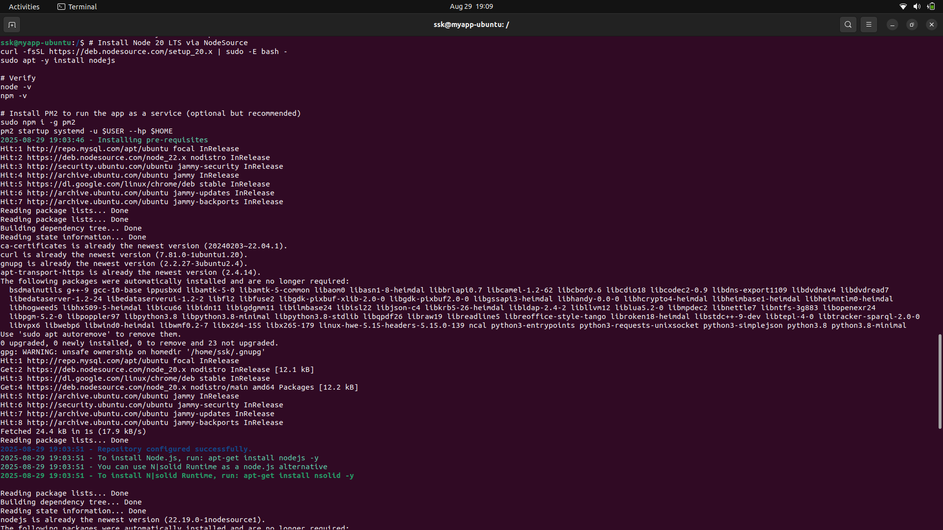

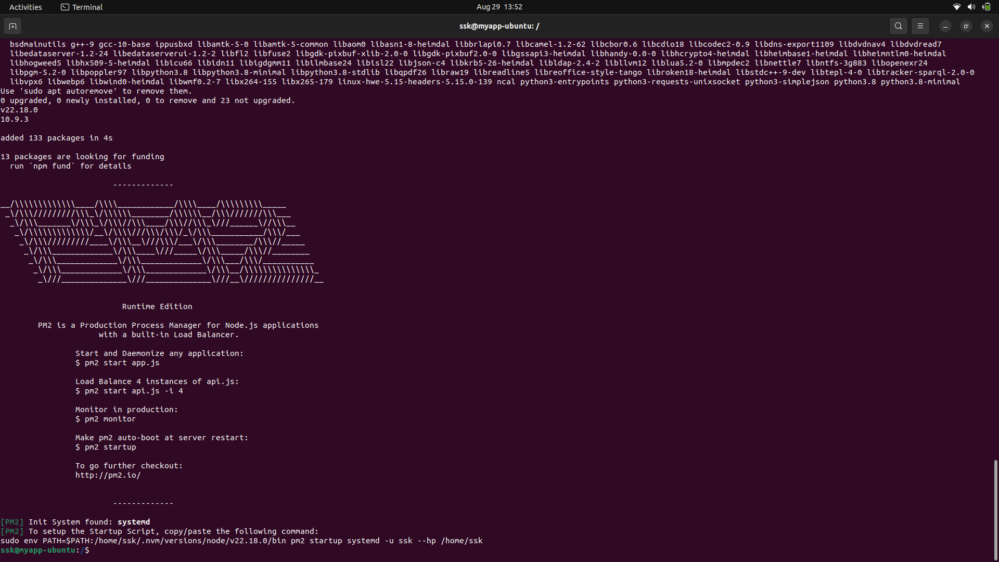

**Install MongoDB Community Server**

# Import MongoDB’s public key

sudo apt-get install -y gnupg

curl -fsSL https://pgp.mongodb.com/server-7.0.asc | \

sudo gpg -o /usr/share/keyrings/mongodb-server-7.0.gpg --dearmor

# Add repo (for Ubuntu 22.04 "jammy"; if 20.04 use "focal")

echo "deb [ signed-by=/usr/share/keyrings/mongodb-server-7.0.gpg ] https://repo.mongodb.org/apt/ubuntu $(. /etc/os-release; echo $UBUNTU_CODENAME)/mongodb-org/7.0 multiverse" | \

sudo tee /etc/apt/sources.list.d/mongodb-org-7.0.list

sudo apt update

sudo apt -y install mongodb-org

# Start & enable

sudo systemctl enable --now mongod

# Check status

systemctl status mongod –no-pager

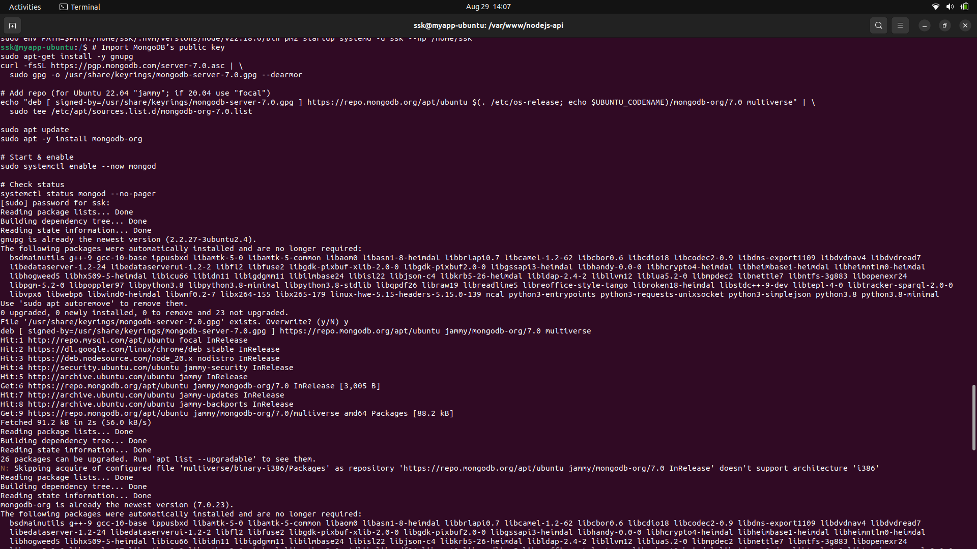

cd /var/www

sudo mkdir nodejs-api && sudo chown $USER:$USER nodejs-api

cd nodejs-api

git clone https://github.com/BL-AniketChile/NodeJs-API .

npm ci || npm install

cat > .env << 'EOF'

MONGODB_URL=mongodb://localhost:27017/demo

PORT=3000

EOF

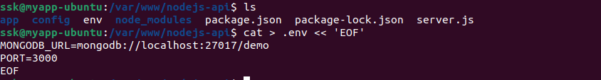

npm start

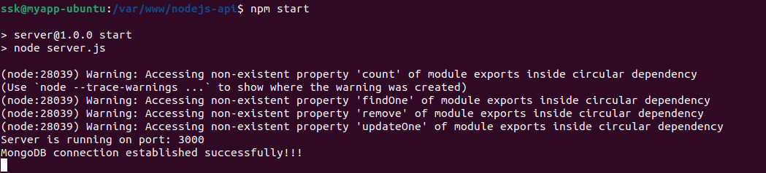

curl -i <http://127.0.0.1:3000/>

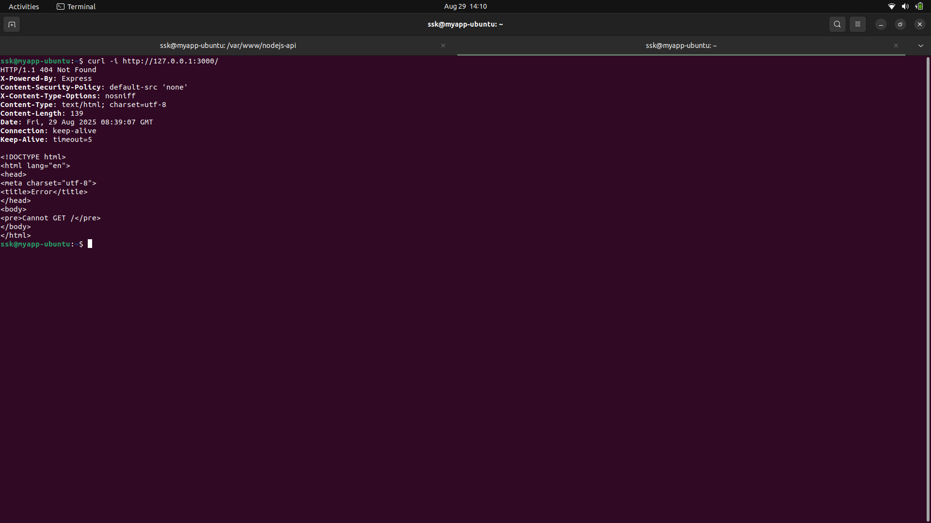

pm2 start npm --name nodejs-api -- start

pm2 save

pm2 list

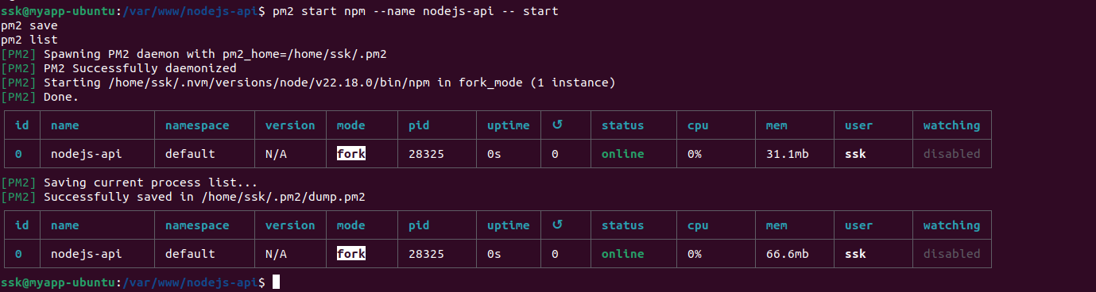

LAN_IP=$(hostname -I | awk '{print $1}')

echo "Using IP: $LAN_IP"

sudo tee /etc/apache2/sites-available/nodejs-api.conf >/dev/null <<EOF

<VirtualHost *:80>

ServerName $LAN_IP

ServerAdmin webmaster@localhost

Header always set X-Content-Type-Options "nosniff"

Header always set X-Frame-Options "SAMEORIGIN"

Header always set X-XSS-Protection "1; mode=block"

ProxyPreserveHost On

ProxyRequests Off

ProxyPass / http://127.0.0.1:3000/

ProxyPassReverse / http://127.0.0.1:3000/

ErrorLog \${APACHE_LOG_DIR}/nodejs-api_error.log

CustomLog \${APACHE_LOG_DIR}/nodejs-api_access.log combined

</VirtualHost>

EOF

sudo a2enmod proxy proxy_http headers rewrite

sudo a2dissite 000-default.conf

sudo a2ensite nodejs-api.conf

sudo systemctl reload apache2

